TABLE OF CONTENTS
INTRODUCTION 2
1.1 Background of the Study 2
1.2 Statement of the Problem 5
1.3 Aim and Objectives of the Study 6
1.4 Research Questions 7
1.5 Significance of the Study 7
1.6 Scope and Limitations of the Study 8
1.7 Definition of Key Terms 9
Blockchain 9
Smart Contract 9
Ethereum 9
Solidity 9
Decentralised Application (DApp) 9
SHA-256 10
NDPR 10
IPFS 10
Gas 10
OpenZeppelin 10
1.8 Organization of the Report 11
CHAPTER TWO 12
LITERATURE REVIEW 12
2.1 Introduction 12
2.2 Blockchain Technology: Concepts and Properties 12
2.2.1 Public versus Private Blockchains 13
2.2.2 Proof of Stake and Energy Efficiency 14
2.3 Smart Contracts on the Ethereum Platform 14
2.3.1 Smart Contract Security Vulnerabilities 15
2.3.2 OpenZeppelin Security Libraries 16
2.4 Cryptographic Hashing: SHA-256 16
2.5 Decentralised Document Storage: IPFS and Pinata 18
2.6 Certificate Fraud in Nigerian Higher Education 19
2.7 The Nigeria Data Protection Regulation 2019 20
2.8 Review of Related Systems 21
2.8.1 NITDA Blockchain Certificate System (2025): Primary Related System 21
2.8.2 Rustemi et al. (2023): Systematic Literature Review, IEEE Access 22
2.8.3 Akinnifesi and Balogun (2025): University of Ibadan 22
2.8.4 Onoshioze, Ahubele and Obahiagbon (2025): BIU Journal 22
2.8.5 Sa'ad et al. (2024): Modibbo Adama University, North-East Nigeria 23
2.8.6 Said et al. (2023): Tanzania 23
2.8.7 Kushwaha et al. (2022): Smart Contract Security, IEEE Access 23
2.8.8 Ifeyemi, Oyedeji and Adebiyi (2024): Nigerian Blockchain Certificate System 24
2.8.9 Adewale, Adewumi and Usman (2021): Blockchain Framework for Nigeria 24
2.8.10 Habib et al. (2022): Blockchain Benefits, Challenges and Applications 24
2.9 Summary of the Literature and Research Gap 25
CHAPTER THREE 28
RESEARCH METHODOLOGY 28
3.1 Introduction 28
3.2 Research Design and Philosophical Paradigm 28
3.2.1 Design Science Research 28
3.2.2 Research Approach 30
3.3 System Requirements Elicitation 31
3.3.1 Population of Study 31
3.3.2 Sample Size and Sampling Technique 31
3.3.3 Stakeholder Identification 31
3.3.4 Primary Data Collection 32
3.4 System Requirements 34
3.4.1 Functional Requirements 34
3.4.2 Non-Functional Requirements 35
3.5 System Architecture 36
3.5.1 Architectural Pattern 37
3.5.2 Technology Stack 39
3.6 Smart Contract Design 40
3.6.1 Contract Architecture 40
3.6.2 Role Structure 41
3.6.3 Certificate Data Structure 42
3.6.4 Core Functions 43
3.6.5 Security Measures 44
3.7 Backend Application Programming Interface Design 44
3.7.1 API Architecture 44
3.7.2 Authentication: EIP-191 Wallet Signatures and JWT 44
3.7.3 MongoDB Data Schemas and NDPR Architecture 45
3.7.4 API Endpoint Summary 46
3.8 Frontend Decentralised Application Design 47
3.8.1 Application Structure 47
3.8.2 Super Admin Panel 47
3.8.3 Registry Admin Dashboard 47
3.8.4 Holder Portal 50
3.8.5 Public Verification Page 50
3.9 NDPR Compliance Architecture 52
3.10 Testing and Evaluation Plan 53
3.10.1 Smart Contract Unit Testing 53
3.10.2 Integration Testing 53
3.10.3 Performance Testing 54
3.10.4 Security Analysis 54
3.10.5 Usability Evaluation 54
3.11 Implementation Plan 56
3.12 Chapter Summary 57
REFERENCES 59

CHAPTER ONE

INTRODUCTION

1.1 Background of the Study
There is more to a university degree certificate than its physical appearance. For a graduating student, it is tangible evidence of years of hard work, academic discipline, and intellectual growth. For the institution that awards it, the certificate is an extension of its credibility and reputation. When a graduate walk into a job interview or submits an application to a postgraduate programme, the certificate does much of the talking. Employers trust it. Licensing bodies act on it. Foreign institutions use it to make admission decisions. That trust is not incidental; it is the very foundation on which those decisions rest. When the trust turns out to be misplaced, the damage reaches far beyond the individual who submitted a false document.
Nigeria has been grappling with certificate fraud for many years, and the evidence is well documented. In its 2022 annual review, the West African Examinations Council found that a notable proportion of certificates brought in for authentication were either outright forgeries or belonged to individuals other than those presenting them (WAEC, 2022). The Economic and Financial Crimes Commission has successfully prosecuted university employees who altered student academic records in exchange for payment, turning institutional databases from reliable sources of truth into instruments of deception (EFCC, 2022). The Independent Corrupt Practices and Other Related Offences Commission has recorded comparable misconduct across a range of institutions (ICPC, 2021). At the national mobilisation level, the National Youth Service Corps continues to find fake academic transcripts at its registration centres, including cases where well-made forgeries are practically indistinguishable from genuine certificates without a direct call to the issuing registry (NYSC, 2021).
Nigerian Army University Biu came into existence under the authority of Act No. 4 of 2018. It is still a relatively young institution, yet it has been growing consistently. Every academic year brings a larger graduating class, and every graduation sends more NAUB certificates into the Nigerian labour market. Like the majority of Nigerian universities, NAUB currently produces paper-based degree certificates whose security depends on printed features. Verifying any one of those certificates requires an employer or institution to write formally to the NAUB registry, wait an unpredictable length of time for a reply, and then take the reply on faith. The process is slow. It is expensive for both sides. It cannot keep up as graduate numbers rise. And it offers absolutely no way to cancel a certificate that was issued wrongly or obtained through dishonest means.
Blockchain technology provides a genuinely sound technical answer to these problems. At its core, a blockchain is a digital ledger that operates simultaneously across many independent computers, where every record is cryptographically anchored to all the records before it (Nakamoto, 2008). No single machine holds the authoritative copy, which means there is no single point an attacker can compromise. Rewriting a past record would require overwhelming the computational resources of the majority of the network, a task that is simply not practical. The ledger also works in one direction only; records are added but never deleted or changed. No administrator, whatever their rank or authority, can alter what has already been written. These three qualities speak directly to the failures that undermine NAUB's current certificate infrastructure.
The Ethereum blockchain, first described by Buterin (2014), extends this foundation by enabling smart contracts. These are pieces of self-executing code that live on the blockchain and carry out their own logic automatically, with no need for any human intermediary to trigger them. A smart contract can spell out exactly which wallet addresses are permitted to issue certificates, what conditions must be satisfied before a certificate can be cancelled, and how a verification request should be resolved. Once deployed, those rules hold firm and no administrator can undo them. Ethereum also made a significant technical shift in September 2022, moving away from an energy-heavy proof-of-work model to a proof-of-stake system that cut its energy use by around 99.95 percent. That change removes the main environmental argument against deploying Ethereum in public sector or institutional settings (Ethereum Foundation, 2023).
The National Information Technology Development Agency has already demonstrated that blockchain-based credentialing can succeed in Nigeria. Its Blockchain Certificate System (NITDA, 2025), accessible at https://nitda-blockchain-cert.vercel.app/, has processed more than 2,500 certificates and logged over 10,000 verification events, showing that the concept is technically viable and accepted at the Nigerian government level. That said, the NITDA system was built specifically for IT service providers under NITDA's own regulatory umbrella. It was never intended for academic degree management. It has no layered administrative structure that reflects how a university actually operates, no portal through which students can access their own records, no formal revocation process, and no framework for compliance with the Nigeria Data Protection Regulation 2019.
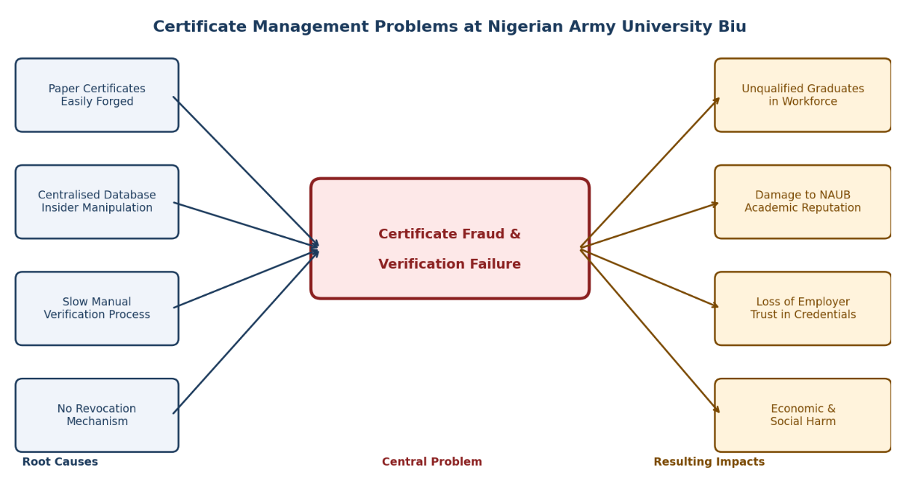
The problem this research addresses is therefore specific and well defined. NAUB currently operates a paper-based certificate system that is exposed to physical forgery, susceptible to insider manipulation of digital records, and completely lacking any mechanism for instant independent verification or revocation. These weaknesses leave the institution and its graduates unprotected against certificate fraud in ways that existing administrative and legal controls do not adequately prevent. This research sets out to solve those problems by designing and building a blockchain-based certificate issuance and verification system made specifically for NAUB. The solution uses Ethereum smart contracts to enforce role-based issuance authority, SHA-256 cryptographic hashing to produce a tamper-evident fingerprint for each certificate, IPFS decentralised storage for certificate documents, and a public verification interface that lets any employer, institution, or regulatory body anywhere in the world confirm the authenticity of a NAUB degree certificate within two seconds, at no cost, and with no need to contact the university.

Figure 1.1: Certificate Management Problems at NAUB: Root Causes and Resulting Impacts
Figure 1.1 illustrates the four root causes of the certificate management problem at NAUB, the central challenge they collectively create, and the four impact areas that result when the problem goes unaddressed. Each root cause maps directly onto a specific technical or structural weakness that the proposed system is designed to resolve, as described throughout this chapter.

1.2 Statement of the Problem
The way NAUB currently handles certificate issuance and verification is undermined by four interconnected failures that together make conditions for fraud far too easy to sustain. The first is that the paper-based degree certificates the institution issues can be physically copied. Research by Ofoegbu and Nwachukwu (2015) found that a commercially active forgery market operates openly across several Nigerian cities, producing convincing replicas of university degrees at prices within reach of a large number of potential buyers. Printed security features offer no real protection against this threat. The second failure is that the centralised academic database is open to insider abuse. Any staff member with access rights has the technical capability to edit grade records and produce certificates that reflect data they have fabricated. Without any form of cryptographic audit trail, those changes can be made and then hidden without leaving any recoverable forensic evidence (Adewale et al., 2021). The third failure is that the verification process is too slow and too costly to serve as a meaningful deterrent. Confirming the legitimacy of a NAUB certificate requires a formal written request to the registry, an uncertain wait for a response, and a reply that cannot itself be independently verified. In practice, most certificate verification in Nigeria never happens at all, because the cost and effort involved are simply too high for most employers and institutions to justify (Kshetri and Voas, 2018). The fourth failure is the total absence of any revocation mechanism. When a certificate is later found to have been issued in error or obtained through fraud, there is no way to notify the employers, regulatory bodies, and institutions that may have already accepted and acted on it. They remain permanently uninformed of any change in that certificate's validity. These four failures together are the problem this research is designed to solve.

1.3 Aim and Objectives of the Study
The primary aim of this study is to design, implement, and evaluate a blockchain-based certificate issuance and verification system built specifically for Nigerian Army University Biu. The system must address the four structural failures identified in Section 1.2 and comply with the Nigeria Data Protection Regulation 2019.
The following specific objectives guide the study:
- To review the relevant literature on blockchain technology, certificate fraud in Nigeria, and existing blockchain credentialing systems, with particular attention to the NITDA Blockchain Certificate System, in order to identify the research gaps that justify this project.
- To analyse the technical and institutional weaknesses of NAUB's current certificate management process and design a blockchain-based decentralised application architecture that addresses them, including smart contract role enforcement, SHA-256 hashing, IPFS document storage, and an NDPR-compliant off-chain data strategy.
- To implement the designed system in full, including the Solidity smart contracts, Node.js backend API, React.js frontend application, MongoDB off-chain database, and IPFS certificate storage integration.
- To evaluate the implemented system against functional correctness, performance, security, usability, and NDPR compliance criteria using unit and integration testing, Slither static analysis, performance benchmarks, and a ten-participant System Usability Scale study.

1.4 Research Questions
This study is structured around the following research questions:
- What are the specific technical and structural weaknesses in the current certificate issuance and verification process at Nigerian Army University Biu, and how do those weaknesses create and sustain conditions that favour certificate fraud?
- How can the core architectural properties of blockchain technology, specifically immutability, decentralisation, transparency, and programmability through smart contracts, be applied to address each of the identified weaknesses at NAUB?
- What smart contract role structure, cryptographic mechanism, and data storage strategy are most appropriate for a certificate system that must be secure, performant, and fully compliant with the Nigeria Data Protection Regulation 2019?
- To what degree does the implemented NAUB blockchain certificate system achieve usability requirements across its principal user roles of Registry Admin, certificate holder, and public verifier?
- Does the implemented system meet the performance, functional correctness, and security characteristics required for real-world deployment at NAUB?

1.5 Significance of the Study
The significance of this study extends across academic, institutional, policy, and practical dimensions.
From a research perspective, this work fills a specific gap in the blockchain credentialing literature: the absence of a fully built and formally evaluated system designed for a Nigerian university context. Prior contributions from Adewale et al. (2021) and Sa'ad et al. (2024) put forward blockchain frameworks for managing Nigerian academic records, but neither carries through to complete system implementation and empirical testing. This project delivers what they left unfinished.

At the level of the institution, the system gives NAUB a working, ready-to-deploy tool. Public verification costs nothing. Paper-based correspondence becomes unnecessary.
Certificate forgery is rendered computationally infeasible. As the university's graduating cohorts grow each year, having a scalable digital verification infrastructure in place becomes increasingly important for maintaining the credibility of NAUB degrees in the labour market.
From a policy standpoint, the findings connect directly to the Federal Government of Nigeria's National Digital Economy Policy and Strategy 2020 to 2030, which names blockchain technology as a priority area for national development (Federal Government of Nigeria, 2020). The work also aligns with NITDA's mandate to advance digital certification standards across Nigerian institutions.
On the practical side, every Nigerian employer, NYSC mobilisation centre, professional regulatory body, and foreign institution that receives a NAUB degree certificate will gain the ability to verify its authenticity independently, instantly, at no cost, and without contacting the university at all. That removes the single most significant barrier to reliable certificate verification in Nigeria's labour market.

1.6 Scope and Limitations of the Study
This study covers the design, full-stack implementation, and structured evaluation of a blockchain-based degree certificate issuance and verification system for Nigerian Army University Biu. The scope is confined to degree certificates only. The system is developed and tested on the Ethereum Sepolia Testnet, with an architecture that can be transferred directly to the Ethereum mainnet or any Ethereum-compatible Layer 2 network.
The study carries several limitations. Because the evaluation was run on a testnet rather than the live Ethereum mainnet, gas cost figures are estimates based on testnet observations rather than actual mainnet conditions. The usability evaluation drew on ten participants, which is in line with established practice for formative usability research (Nielsen, 1993) but does not provide the statistical power needed for population-level conclusions. The smart contracts have not gone through a professional third-party security audit, which would be a mandatory requirement before any mainnet production deployment. The study also does not include a dedicated mobile application; the system's interface is delivered through a responsive web browser that functions on both desktop and mobile devices.

1.7 Definition of Key Terms

Blockchain
A blockchain is a distributed, append-only digital ledger where records are stored in a chain of cryptographically linked blocks. Each block holds the hash of the one before it. The ledger operates simultaneously across a peer-to-peer network of independent nodes, and no individual party can change any historical record without the agreement of the network majority (Nakamoto, 2008).

Smart Contract
A smart contract is a programme that lives directly on a blockchain and is executed by the blockchain's virtual machine. Its rules and logic are locked in at the point of deployment and enforce themselves automatically, without any human intermediary. In this system, smart contracts determine who is authorised to issue certificates and how verification queries are resolved (Buterin, 2014).

Ethereum
Ethereum is a public, open-source blockchain platform designed to support smart contracts through its Ethereum Virtual Machine. In September 2022, the network moved to a proof-of-stake consensus mechanism, which reduced its energy consumption by approximately 99.95 percent (Ethereum Foundation, 2023).

Solidity
Solidity is a statically typed, contract-oriented high-level programming language built for writing smart contracts on the Ethereum Virtual Machine. Version 0.8.x introduced built-in protection against arithmetic overflow and underflow, removing one of the most commonly exploited vulnerability types in Ethereum contract history.

Decentralised Application (DApp)
A decentralised application is a software system whose core logic runs on a distributed peer-to-peer network rather than on a centralised server. The NAUB blockchain certificate system is a DApp; the trust it provides is grounded in its smart contracts on the Ethereum blockchain.

SHA-256
SHA-256 is a cryptographic hash function that takes any input and produces a fixed 256-bit output. It is deterministic, one-way, and collision-resistant, making it a reliable tool for generating a unique, tamper-evident fingerprint for each certificate in this system. It is standardised by the National Institute of Standards and Technology (NIST, 2015).

NDPR
The Nigeria Data Protection Regulation is the primary legal framework governing how personal data belonging to Nigerian citizens is collected, processed, and stored. NITDA issued it in January 2019. It sets out seven data protection principles, including data minimisation and the right to erasure (NITDA, 2019).

IPFS
The InterPlanetary File System is a peer-to-peer distributed file storage protocol in which each file is identified by a Content Identifier derived from the cryptographic hash of its contents. This system uses IPFS to provide permanent, tamper-detectable archival storage for certificate PDF documents (Benet, 2014).

Gas
Gas is the measure of computational work performed on the Ethereum network. Read-only smart contract functions do not consume gas because they do not alter blockchain state. Certificate verification in this system uses a read-only view function, which is why it is permanently free for any user anywhere in the world.

OpenZeppelin
OpenZeppelin is an open-source framework that offers professionally audited and community-reviewed smart contract security modules for Ethereum. This system uses its AccessControl, Pausable, and ReentrancyGuard modules to manage roles, provide an emergency stop capability, and guard against reentrancy attacks (OpenZeppelin, 2023).

1.8 Organization of the Report
This report is structured across five chapters. Chapter One has set out the research context, identified the problem, stated the aim and objectives, posed the research questions, argued for the significance of the study, defined its scope and limitations, and introduced the key technical terms used throughout.
Chapter Two presents a thorough review of the relevant literature, covering the foundations of blockchain technology, smart contract security, certificate fraud in Nigeria, the NITDA Blockchain Certificate System and its gaps, comparable blockchain credentialing work from Nigeria and other countries, cryptographic mechanisms, IPFS storage, and the Nigerian data protection regulatory framework.
Chapter Three describes the research methodology, covering the Design Science Research paradigm, primary data collection methods, system requirements, the full system architecture, smart contract design, backend API design, frontend application design, the NDPR compliance data strategy, and the phased implementation plan.
Chapter Four presents the implementation outcomes and evaluation findings, covering functional test results, gas cost analysis, performance benchmarks, Slither security analysis outcomes, usability evaluation scores, and NDPR compliance verification.
Chapter Five concludes the report with a summary of findings, direct answers to the research questions, the project's contributions to knowledge, recommendations for institutional adoption, and directions for future research.

CHAPTER TWO

LITERATURE REVIEW

2.1 Introduction
This chapter presents a structured review of the academic and professional literature that is relevant to the design and implementation of a blockchain-based certificate issuance and verification system for Nigerian Army University Biu. The review is organised by theme. It starts with the theoretical foundations of blockchain technology, then moves through smart contract security, cryptographic hashing, decentralised file storage, the Nigerian personal data regulatory environment, and the specific problem of certificate fraud in Nigerian higher education. It closes with a detailed critical review of ten related systems and studies. Each section draws specific conclusions that feed directly into the design decisions described in Chapter Three.
Ten primary sources were selected on the basis of their direct relevance to the technical, institutional, and regulatory dimensions of the research problem. Six are peer-reviewed journal articles published between 2021 and 2025. Two were published in Nigerian university journals, providing institutional context closely comparable to the NAUB environment. One is a systematic literature review covering 34 studies in the blockchain credentialing field. The tenth is the NITDA Blockchain Certificate System, treated as a primary reference because it is a live operational system whose design and limitations can be directly observed rather than inferred from a published description alone.

2.2 Blockchain Technology: Concepts and Properties
Blockchain technology was formally introduced by Nakamoto (2008), who described a peer-to-peer electronic cash system that removed the need for a trusted central authority to process transactions. Although Nakamoto's application was financial, the underlying data structure proved to be broadly applicable. A chain of cryptographically linked blocks maintained across a distributed network of independent computers turned out to be a general-purpose mechanism for creating tamper-evident records in any setting where trust between multiple parties is hard or expensive to establish through conventional institutional means.
Habib et al. (2022) provide a thorough treatment of the core blockchain properties that make it well suited for institutional record management. Four of those properties are especially relevant to certificate issuance and verification. Immutability means that once a record is committed to the blockchain, altering it requires recalculating the cryptographic proofs for every subsequent block and outpacing the combined computing power of the entire network, which is not economically or computationally feasible at any meaningful scale. Decentralisation means no single entity controls the ledger, so the failure, corruption, or compromise of any one participant does not affect the records held by the rest of the network. Transparency means every participant with network access can independently verify any record at any time, without needing the cooperation of the original issuer or any intermediary. Auditability means the complete history of every record, including who created it, when, and under what circumstances, is permanently preserved and accessible to anyone with access to the network.
These four properties correspond directly to the four structural failures identified in Chapter One. Immutability addresses both the physical reproducibility of paper certificates and the vulnerability of centralised databases to insider manipulation. Decentralisation removes the single administrative chokepoint through which a compromised staff member could alter records and hide the evidence. Transparency makes instant verification by any employer or institution possible, without any contact with NAUB. The permanent, publicly accessible audit trail ensures that a certificate revocation, once recorded on-chain, will be encountered by every future verifier regardless of when they submit their query.

2.2.1 Public versus Private Blockchains
Blockchain networks range from fully public and permissionless to fully private and permissioned. A public blockchain such as Ethereum allows any entity to participate, submit transactions, and read the ledger without requiring approval from any central authority. A private or consortium blockchain restricts participation to a defined and approved set of entities (Habib et al., 2022). For the specific purpose of certificate verification, this distinction is decisive.

A certificate issued on a public blockchain can be verified by any employer, institution, or regulatory body anywhere in the world, without requiring that verifier to be registered with or approved by NAUB. A certificate on a private blockchain can only be verified by entities that have been granted access to that private network. Given that the primary use cases for NAUB certificate verification include foreign institutions, NYSC mobilisation centres, and private employers, none of whom will register with any NAUB-controlled access system, a public blockchain is the only architecture that achieves truly open and frictionless verification. This project therefore uses the Ethereum public blockchain, specifically the Sepolia Testnet for development and evaluation, with a direct pathway to Ethereum mainnet for production deployment.

2.2.2 Proof of Stake and Energy Efficiency
One of the most persistent institutional objections to Ethereum was its historically high energy consumption under proof-of-work consensus. The Ethereum Foundation completed the transition to proof-of-stake consensus in September 2022, an event known as the Merge, which reduced the network's energy consumption by approximately 99.95 percent while preserving all of its security, immutability, and decentralisation properties (Ethereum Foundation, 2023). This transition substantially reduces the environmental and reputational objection to deploying Ethereum in a public institution such as a Nigerian university, making it an appropriate choice for a system intended for eventual institutional adoption.

2.3 Smart Contracts on the Ethereum Platform
The concept of self-executing digital contracts was proposed by Szabo (1994) as a theoretical idea that was waiting for a suitable execution environment. Buterin (2014) provided that environment by proposing Ethereum as a blockchain platform with a Turing-complete virtual machine capable of executing arbitrary code stored directly on the blockchain. In the Ethereum context, a smart contract is a programme whose bytecode is deployed to a specific address on the blockchain, where it executes automatically and deterministically whenever its functions are called by a transaction or by another contract. Once deployed, the code of a smart contract cannot be altered, and its execution cannot be stopped or reversed by any party, including the entity that originally deployed it.
For certificate management, these properties create institutional trust guarantees that paper-based and centralised digital systems cannot replicate. A CertificateRegistry smart contract that specifies which wallet addresses hold the authority to issue certificates, what data must accompany every issuance, and how verification queries are handled cannot be overridden by any administrator after deployment. A Registry Admin who has been assigned the CERTIFICATE_ROLE cannot issue a certificate without providing all required fields, because the smart contract rejects any transaction that violates its validation logic, automatically and permanently, without any human review. The Super Admin, acting through the SUPERADMIN_ROLE, cannot accidentally or deliberately extend issuance privileges to an unauthorised wallet, because the role assignment logic is enforced at the code level.

2.3.1 Smart Contract Security Vulnerabilities
The security of smart contracts is an active and critical research area. Kushwaha et al. (2022) conducted a systematic review of Ethereum smart contract security vulnerabilities in IEEE Access, examining 168 studies and classifying vulnerabilities into twelve major categories. Three categories are most directly relevant to the design of the CertificateRegistry contract in this project.
Reentrancy attacks occur when a malicious external contract calls back into the victim contract before the victim contract has completed updating its own internal state. This allows the attacker to execute the same function multiple times while the contract still reflects its pre-update state. Kushwaha et al. (2022) identify reentrancy as one of the most exploited vulnerability classes in Ethereum contract history. This project prevents reentrancy by adopting the OpenZeppelin ReentrancyGuard module and by strictly following the checks-effects-interactions pattern in every state-modifying function, ensuring that all internal state changes are completed before any external calls are made.
Access control vulnerabilities arise when contract functions that should be restricted to specific authorised roles are callable by any wallet address. In a certificate contract, this failure would allow any external party to issue, revoke, or delete certificates. Kushwaha et al. (2022) found access control errors to be consistently present across the body of reviewed studies. This project addresses the vulnerability by using the OpenZeppelin AccessControl module, which provides a professionally audited, widely deployed role management system that has been reviewed by independent security researchers and tested in thousands of production contracts.
Integer arithmetic errors, including overflow and underflow, were a source of exploitable vulnerabilities in early Solidity contracts because the EVM performed arithmetic modulo the maximum integer size without reverting. From Solidity version 0.8.0 onwards, the compiler includes automatic overflow and underflow checks that cause any arithmetic operation exceeding the bounds of the integer type to revert the transaction rather than wrap silently (Solidity Documentation, 2023). By specifying Solidity version 0.8.19 in the contract pragma, this project inherits this protection by default without any additional code.

2.3.2 OpenZeppelin Security Libraries
OpenZeppelin Contracts is an open-source library of smart contract security modules that has been professionally audited and is maintained by a dedicated team of security researchers. It is the most widely used smart contract security library in the Ethereum ecosystem (OpenZeppelin, 2023). This project incorporates three OpenZeppelin modules. AccessControl provides the role-based permission system that separates Super Admin governance from Registry Admin certificate issuance, enforcing the principle of least privilege at the contract level. Pausable provides an emergency stop mechanism that allows the Super Admin to halt all write operations to the contract in the event of a detected attack or critical system error, without requiring a full contract redeployment. ReentrancyGuard provides the nonReentrant modifier that prevents reentrancy attacks on state-modifying functions. The use of these audited modules rather than custom implementations is a direct application of the security best practice recommended by Kushwaha et al. (2022).

2.4 Cryptographic Hashing: SHA-256
A cryptographic hash function takes an input of any length and produces a fixed-length output called a hash or digest, with four essential security properties. Determinism means the same input always produces the same output. The avalanche effect means any change to the input, however small, produces a completely different output with no observable relationship to the original. Pre-image resistance means it is computationally infeasible to recover the original input from the hash alone. Collision resistance means it is computationally infeasible to find two distinct inputs that produce the same hash output (NIST, 2015).
SHA-256, the Secure Hash Algorithm producing a 256-bit output, is standardised by the National Institute of Standards and Technology in Federal Information Processing Standard 180-4 (NIST, 2015). Its 256-bit output space contains 2 to the power of 256 possible values, making brute-force collision search computationally infeasible with any foreseeable technology. SHA-256 is the hash function used in the Bitcoin blockchain, in TLS certificate fingerprints, and in the digital signature schemes of most government and commercial PKI systems worldwide.
In this project, SHA-256 serves two distinct roles. First, it generates the certificate hash. When a Registry Admin completes the certificate issuance form, the browser concatenates all certificate fields and passes the result through the SHA-256 algorithm using the Web Crypto API, a cryptographic interface built into all modern browsers that requires no external library. The resulting 256-bit hash is the unique, tamper-evident fingerprint of that certificate stored on the blockchain. Any future attempt to verify the same certificate by entering the same fields will produce the same hash, confirming authenticity. Any attempt to alter even a single character of any field produces a completely different hash with no blockchain record, making tampering immediately and permanently detectable. Second, SHA-256 generates the anonymised identity hash stored alongside each certificate. The holder's full name and date of birth are hashed before being stored anywhere, ensuring that the on-chain record contains no personally identifiable information, satisfying the NDPR data minimisation principle discussed in Section 2.7.
The SHA-256 hashing approach for certificate fingerprinting is independently adopted by Akinnifesi and Balogun (2025), Sa'ad et al. (2024), and Adewale et al. (2021), confirming it as the established consensus approach for blockchain-based academic certificate systems in the Nigerian literature.

2.5 Decentralised Document Storage: IPFS and Pinata
Storing full certificate PDF documents directly on the Ethereum blockchain is not economically practical because gas fees scale with data size. A certificate PDF document stored entirely on-chain at typical mainnet gas prices would cost hundreds of US dollars per certificate, making the system unaffordable for routine institutional use (Ethereum Foundation, 2023). The InterPlanetary File System, described by Benet (2014), provides a cost-effective alternative that preserves the tamper-detection properties of blockchain storage for document content without incurring on-chain storage costs.
IPFS is a peer-to-peer distributed file storage protocol where every file is identified not by its location, such as a URL, but by a Content Identifier derived from the cryptographic hash of the file's contents. This content-addressing property means that if any byte of a stored certificate document changes, its Content Identifier changes with it, making any silent modification of the stored document immediately detectable. The Content Identifier is a short string that can be stored on the Ethereum blockchain at negligible gas cost, permanently linking the on-chain certificate record to the off-chain certificate document. Any verifier who wishes to examine the original certificate PDF retrieves it from IPFS using the Content Identifier and can confirm its integrity by checking that its hash matches the identifier.
Pinata is a commercial IPFS pinning service that guarantees the permanent availability of pinned documents by maintaining them on dedicated infrastructure, preventing them from being removed by IPFS nodes that no longer hold them in response to reduced access demand. For institutional certificate archival, where documents must remain accessible years or decades after issuance, a pinning service is a necessary component of the architecture. The Pinata SDK is used in the Node.js backend of this project to handle all IPFS uploads and return the Content Identifier for on-chain and off-chain storage. IPFS via Pinata for certificate document storage is the approach adopted by Akinnifesi and Balogun (2025), Sa'ad et al. (2024), Onoshioze et al. (2025), and Ifeyemi et al. (2024), confirming it as the established standard for this class of system.

2.6 Certificate Fraud in Nigerian Higher Education
Certificate fraud in the Nigerian higher education system is a well-documented and economically significant problem. Adewale et al. (2021), in their comprehensive review of Nigerian academic certificate authentication practices, document a commercially organised market for forged credentials operating across multiple Nigerian cities. They identify three categories of fraud: entirely fabricated certificates purporting to have been issued by real universities, genuine certificates with altered names or grades, and authentic certificates presented by persons other than their legitimate holders. The third category requires no forgery expertise at all and is particularly difficult to detect without a system that cryptographically links a certificate to a specific holder's verifiable identity.
The consequences of unchecked certificate fraud extend well beyond the individuals who submit false credentials. Employers and regulatory bodies that cannot rely on academic certificates either invest heavily in manual verification processes or reduce the weight they assign to formal qualifications in hiring and licensing decisions (Kshetri and Voas, 2018). Either response penalises honest graduates who hold legitimate credentials, either by subjecting them to prolonged and intrusive verification or by operating in a labour market where their qualifications are systematically discounted because the market has lost confidence in the credentialing system as a whole.
Sa'ad et al. (2024), working in the North-East Nigerian context at Modibbo Adama University Yola, the geopolitical zone directly comparable to NAUB, found that manual certificate verification in that region requires written correspondence with university registries, response times of weeks to months, and no formal mechanism for verifying the identity of the registry official who provides the verification response. This finding confirms that the problems documented at the national level by Adewale et al. (2021) are present in the specific regional environment of this project. Said et al. (2023), examining the equivalent problem in Tanzania, confirm that it is a shared challenge across sub-Saharan African universities operating similar paper-based systems, suggesting that the solution proposed by this project has applicability beyond the NAUB context.

2.7 The Nigeria Data Protection Regulation 2019
The Nigeria Data Protection Regulation 2019 was issued by NITDA under the authority of the NITDA Act and came into force in January 2019 (NITDA, 2019). It is the primary legal instrument governing the collection, processing, storage, and transfer of personal data relating to Nigerian citizens and residents. The NDPR establishes seven data protection principles: lawfulness and fairness, purpose limitation, data minimisation, accuracy, storage limitation, integrity and confidentiality, and accountability. Organisations that collect or process personal data of Nigerian citizens are bound by these principles regardless of where the data is stored.
Three NDPR principles have direct architectural implications for this project. The data minimisation principle requires that no more personal data than is strictly necessary for the specified purpose be collected or processed. Applied to a blockchain certificate system, this prohibits writing student personal details to the Ethereum blockchain, where they would be permanently visible to the entire world, when only the cryptographic hash of those details is necessary to achieve the verification purpose. The purpose limitation principle prohibits using personal data collected for certificate management for any other purpose without separate consent. The storage limitation principle, combined with the right to erasure provided under Article 3.1(6), requires that personal data be deletable on the request of the data subject.
The right to erasure creates an apparent conflict with the immutability of blockchain records. If personal data is stored on the blockchain, it cannot be deleted, making compliance with the right to erasure technically impossible. This project resolves this conflict through a strict off-chain and on-chain data separation architecture. No personally identifiable information is ever written to the Ethereum blockchain. Student names, dates of birth, matriculation numbers, and all other personal fields reside exclusively in the MongoDB database. The blockchain stores only the SHA-256 hash of those fields, a one-way transformation that cannot be reversed to recover the original personal data. When a student exercises the right to erasure, the MongoDB records are deleted. The on-chain hash remains as an anonymous mathematical value with no recoverable connection to any identifiable person, satisfying the NDPR requirement without any blockchain modification.

A significant finding of this literature review is that none of the existing Nigerian blockchain certificate systems reviewed, including the NITDA Blockchain Certificate System (NITDA, 2025), the Akinnifesi and Balogun (2025) University of Ibadan system, and the Ifeyemi et al. (2024) system, address the NDPR in their published documentation. All three systems process personal data of Nigerian citizens and are therefore subject to the regulation. The explicit NDPR compliance architecture of this project is a substantive contribution to responsible blockchain deployment practice in the Nigerian regulatory context.

2.8 Review of Related Systems
This section reviews the ten primary sources in this study in order of their direct relevance to the NAUB context, from the most closely comparable operational system to the most general theoretical foundation.

2.8.1 NITDA Blockchain Certificate System (2025): Primary Related System
The National Information Technology Development Agency Blockchain Certificate System (NITDA, 2025), accessible at https://nitda-blockchain-cert.vercel.app/, is the most directly comparable operational blockchain certificate system in Nigeria and serves as the primary reference system for this project. The NITDA system issues tamper-proof blockchain certificates to IT service providers certified by NITDA. It has issued over 2,500 certificates and recorded over 10,000 verification events, demonstrating that blockchain certificate issuance is technically viable and institutionally accepted in the Nigerian government context. Certificate verification is available through a certificate ID or QR code scan and returns a result instantly without requiring verifier registration or payment.
Seven limitations were identified through direct examination of the system. The scope is restricted to IT service providers and provides no mechanism for academic degree certificate management. The system operates through a single Admin Portal with no separation of administrative roles or levels of authority. No multi-tier governance structure is documented or visible. No student or graduate holder portal is provided. No certificate revocation mechanism is documented. No NDPR compliance architecture is described. No academic-specific data fields, including programme of study, class of degree, or matriculation number, are supported. These limitations collectively define the gap that the proposed NAUB system fills.

2.8.2 Rustemi et al. (2023): Systematic Literature Review, IEEE Access
Rustemi et al. (2023) published a systematic review of blockchain-based academic certificate verification systems in IEEE Access, covering 34 studies published between 2016 and 2022. Their review provides the most comprehensive mapping of the global research landscape available. Key findings include that Ethereum is used in 68 percent of reviewed systems, IPFS in 54 percent, and SHA-256 in the majority of hash-based certificate fingerprinting implementations. These statistics validate the technology choices made in this project as the established consensus approach rather than experimental selections. Critically, the review found that implementations designed specifically for sub-Saharan African institutions are severely underrepresented, and identified context-specific systems for developing-country universities as a significant research gap. This finding directly supports the research justification of this project.

2.8.3 Akinnifesi and Balogun (2025): University of Ibadan
Akinnifesi and Balogun (2025) implemented a blockchain-based certificate verification system for a Nigerian university using the same core technology stack as this project: Ethereum, Solidity, IPFS, React.js, and Node.js. They reported 98 percent accuracy in detecting forged certificates and verification response times consistently under two seconds. This study is the most directly comparable Nigerian university implementation and independently validates the technology choices of this project. However, the authors do not address NDPR compliance, do not implement a multi-tier administrative role structure, and do not provide a dedicated student holder portal. Their work confirms that the approach is technically sound in the Nigerian university context; this project extends it by addressing the administrative, regulatory, and contextual gaps they left open.

2.8.4 Onoshioze, Ahubele and Obahiagbon (2025): BIU Journal
Onoshioze et al. (2025) published a blockchain certificate verification framework in the BIU Journal of Basic and Applied Sciences, making it the most institutionally proximate related work to this project by journal affiliation. Their framework uses Ethereum, Solidity, and NFT-based certificate tokenisation. The NFT approach differs from the hash-based approach used in this project in a significant way: NFT tokens can be transferred between wallets, which creates potential for a holder to pass their certificate token to another person. For institutional degree certificates, where the binding of a credential to a specific individual is the core security requirement, transferability is an undesirable property. The hash-based approach used in this project is more conservative and more appropriate for this purpose.

2.8.5 Sa'ad et al. (2024): Modibbo Adama University, North-East Nigeria
Sa'ad et al. (2024) implemented a blockchain-based personal records system at Modibbo Adama University Yola in the International Journal of Development Mathematics. As a federal university in the same geopolitical zone as NAUB, this study is geographically and institutionally the closest comparable work available. Their system uses SHA-256 hashing, IPFS, DApp architecture, and on-chain revocation functionality. They document specific adoption barriers in the North-East Nigerian context, including limited staff familiarity with blockchain wallets, variable internet connectivity, and the cost of gas fees in Nigerian Naira terms. These barriers are directly relevant to NAUB and inform the adoption recommendations in Chapter Five. Their confirmation that on-chain revocation is technically feasible and institutionally valuable in a comparable Nigerian university provides strong support for including revocation as a core requirement of this project.

2.8.6 Said et al. (2023): Tanzania
Said et al. (2023) proposed a blockchain-based certificate verification model for Tanzanian universities in Engineering, Technology and Applied Science Research. Their study confirms that the certificate fraud and manual verification problems documented in Nigeria are shared across sub-Saharan African universities and that most existing blockchain credentialing implementations fail to address the specific contextual barriers of African institutions. Their finding that the primary adoption barriers are institutional rather than technical, specifically lack of administrative ownership and insufficient staff training, reinforces the importance of the governance and training recommendations in Chapter Five of this project.

2.8.7 Kushwaha et al. (2022): Smart Contract Security, IEEE Access
Kushwaha et al. (2022) conducted a systematic review of security vulnerabilities in Ethereum smart contracts in IEEE Access, examining 168 studies. As discussed in detail in Section 2.3.1, this paper is the primary theoretical justification for the smart contract security design of this project. Every security mechanism adopted in the CertificateRegistry contract is directly traceable to a finding or recommendation in Kushwaha et al. (2022). The paper also validates the use of Slither, a widely cited static analysis tool for Solidity, as part of the security evaluation methodology.

2.8.8 Ifeyemi, Oyedeji and Adebiyi (2024): Nigerian Blockchain Certificate System
Ifeyemi et al. (2024) published a Nigerian blockchain certificate verification system using the Celo blockchain, QR code verification, and MongoDB for off-chain personal data storage in ITEGAM-JETIA. Their use of MongoDB alongside a blockchain for on-chain hashes independently validates the data architecture adopted in this project. The choice of Celo rather than Ethereum is motivated by lower transaction fees, but Ethereum is preferred in this project for its larger developer ecosystem, more mature security tooling, and longer production track record. Both the Celo and Ethereum approaches achieve the same fundamental separation of on-chain and off-chain data, confirming this architecture as the appropriate solution for NDPR-compliant certificate management.

2.8.9 Adewale, Adewumi and Usman (2021): Blockchain Framework for Nigeria
Adewale et al. (2021) published one of the most cited Nigerian papers on blockchain-based academic certificate authentication in the International Journal of Advanced Computer Science and Applications. Their paper documents the scale and patterns of certificate fraud in Nigeria and proposes a conceptual blockchain framework for authentication. The paper explicitly acknowledges that full implementation and evaluation are left as future work. This project directly fulfils that future work. Where Adewale et al. (2021) propose a framework, this project delivers a working system. Where their contribution is conceptual, this project is empirical. This relationship makes Adewale et al. (2021) both the most important Nigerian conceptual predecessor of this project and the clearest indicator of the specific gap it fills.

2.8.10 Habib et al. (2022): Blockchain Benefits, Challenges and Applications
Habib et al. (2022) published a comprehensive survey of blockchain technology benefits, challenges, and applications across multiple domains in Future Internet. This paper provides the broad theoretical foundation for the blockchain property analysis in Section 2.2 and the challenge taxonomy that informs the limitations section of Chapter Three. Habib et al. (2022) specifically identify education and credentialing as one of the five highest-potential blockchain application domains, based on their analysis of trust requirements, the geographic distribution of verifiers, the permanence of records needed, and the high cost of existing verification processes. This assessment provides independent theoretical support for the research direction of this project.

2.9 Summary of the Literature and Research Gap
The literature reviewed in this chapter establishes four converging conclusions that together provide the theoretical and empirical justification for this project. First, blockchain technology possesses the immutability, decentralisation, transparency, and auditability properties that directly resolve the structural failures of paper-based and centralised digital certificate systems, as documented by Habib et al. (2022) and confirmed by Rustemi et al. (2023). Second, the technology stack selected for this project represents the established consensus approach validated across the international and Nigerian literature, with Ethereum, Solidity, SHA-256, IPFS, Node.js, MongoDB, and React.js appearing consistently across independently developed systems. Third, certificate fraud is a well-documented problem in Nigerian higher education whose specific technical manifestations are addressed directly by the system designed in this project, as argued by Adewale et al. (2021) and confirmed for the North-East Nigerian context by Sa'ad et al. (2024). Fourth, the NDPR 2019 creates specific, binding obligations regarding personal data that no existing Nigerian blockchain certificate system has addressed in its design, and the off-chain data separation architecture of this project is the correct technical implementation of those obligations.

The comparative analysis table below summarises the seven design requirements identified for the NAUB system and shows which of the reviewed systems satisfies each requirement. No existing system satisfies all seven requirements. This project is the only system in the reviewed literature that does.

Feature / Capability | NITDA (2025) | Akinnifesi & Balogun (2025) | Onoshioze et al. (2025) | Sa'ad et al. (2024) | Ifeyemi et al. (2024) | Adewale et al. (2021) | This Project
University degree scope | No | Yes | Yes | Partial | Yes | Yes | Yes
Multi-tier admin role structure | No | No | No | No | No | No | Yes
Student / holder portal | No | No | No | No | No | No | Yes
On-chain certificate revocation | No | No | No | Yes | No | No | Yes
NDPR compliance architecture | No | No | No | No | No | No | Yes
Multiple verification input methods | No | No | No | No | No | No | Yes
Full implementation and evaluation | Yes | Yes | Partial | Yes | Yes | No | Yes

Table 2.1: Comparative Analysis of Related Blockchain Certificate Systems Against NAUB Requirements

The pattern visible in the final column of Table 2.1 confirms that all seven requirements are met by the proposed NAUB system. The cells distributed across the other six systems illustrate the specific gaps each leaves open and confirm that no existing system, including the NITDA Blockchain Certificate System which is the most operationally advanced, achieves the full combination of features required for an academically sound, institutionally appropriate, and legally compliant university certificate system in the Nigerian context. Chapter Three describes the methodology and architecture through which these requirements are met.

CHAPTER THREE

RESEARCH METHODOLOGY

3.1 Introduction
This chapter sets out the research approach, system design, and implementation strategy used to develop the NAUB Blockchain Certificate System. It opens by establishing the philosophical and methodological framework that shapes the research, and justifies the choice of Design Science Research as the paradigm most fitting for a project whose primary output is a working artefact rather than a test of an existing theory. The chapter then presents the methods used to gather system requirements, covering the primary data collection instruments and the stakeholder analysis that informed them. It proceeds through a detailed account of the system architecture, the smart contract design, the backend API design, the frontend decentralised application design, the data storage strategy and its NDPR compliance framework, and the testing and evaluation plan. Taken together, these sections form a complete and reproducible record of how the proposed system was designed, built, and evaluated.

3.2 Research Design and Philosophical Paradigm

3.2.1 Design Science Research
Design Science Research is a research paradigm where the primary output of the work is a novel, purposeful artefact that solves a specific problem in a given context, and where the research contribution lies both in the artefact itself and in the rigorous evaluation that demonstrates its utility (Hevner et al., 2004). It is widely adopted in information systems and computing research because it aligns the research process with the engineering process. The researcher does not merely observe or measure something that already exists; instead, they actively construct a solution, evaluate it against the problem it was designed to address, and communicate both the solution and the findings in a form that others can replicate, extend, or critique.

The Design Science Research paradigm is appropriate for this project for three reasons. First, the problem being addressed is a real-world institutional problem at Nigerian Army University Biu, not an abstract theoretical one. The artefact produced must solve that specific problem in that specific context in order to constitute a valid research contribution. Second, the literature reviewed in Chapter Two confirms that the most significant gap in the existing research is the absence of a working, evaluated implementation. Adewale et al. (2021) explicitly called for implementation-oriented research as the necessary next step beyond their conceptual framework. Third, evaluating the artefact against measurable criteria covering functional correctness, performance, security, usability, and NDPR compliance produces empirical evidence that contributes to knowledge about how blockchain certificate systems can be designed for the Nigerian university context.
The Design Science Research process followed in this project is structured around the six activities defined by Peffers et al. (2007): problem identification and motivation, definition of objectives for a solution, design and development of the artefact, demonstration of the artefact in use, evaluation of the artefact against the defined objectives, and communication of the research. These six activities map directly onto the five chapters of this project. Chapter One addresses problem identification and motivation. Chapter Two establishes the knowledge base that informs the design objectives. Chapter Three covers design and development. Chapter Four presents demonstration and evaluation. Chapter Five communicates conclusions and recommendations. Figure 3.1 below illustrates the complete DSR cycle as applied to this research.

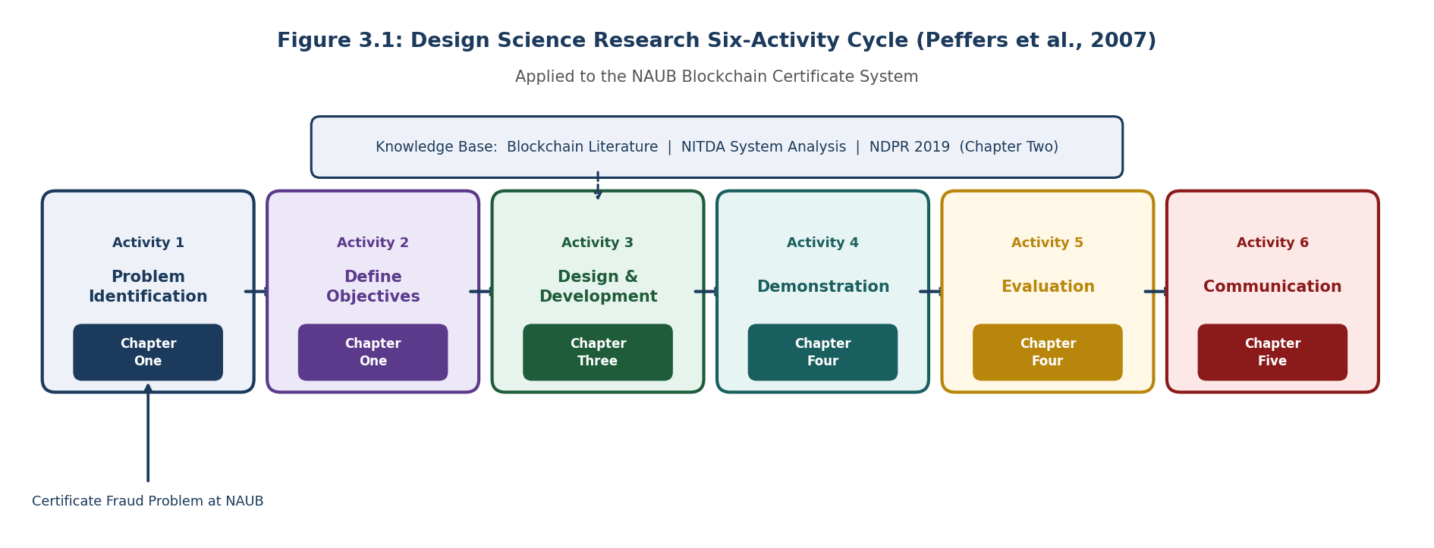

Figure 3.1: Design Science Research Six-Activity Cycle Applied to the NAUB Blockchain Certificate System (Peffers et al., 2007)

3.2.2 Research Approach
The research approach combines primary data collection, through structured requirement elicitation and a System Usability Scale evaluation study, with secondary data analysis through the literature review conducted in Chapter Two. The primary data collection serves two distinct purposes at different stages of the project. At the design stage, it informs the functional and non-functional requirements of the system through structured interviews with key stakeholders at NAUB. At the evaluation stage, it generates the quantitative usability data that allows the system to be assessed against the usability dimension of the research objectives.
A quantitative evaluation approach was adopted for the performance, security, and usability dimensions of the system evaluation, because these dimensions can be expressed as measurable values that allow direct comparison with the related systems reviewed in Chapter Two and with the performance targets specified in the non-functional requirements. A qualitative dimension is incorporated through the observation notes collected during the usability sessions, which capture aspects of the user experience that are not fully expressed by the SUS questionnaire score alone.

3.3 System Requirements Elicitation

3.3.1 Population of Study
The population of this study comprises all persons who are directly involved in or affected by the certificate issuance and verification process at Nigerian Army University Biu. This population includes the university authority represented by the Office of the Registrar and the Vice Chancellor, the central academic registry staff responsible for day-to-day record management and certificate issuance, the student and graduate body whose credentials are managed by the system, and the external ecosystem of verifiers including employers, the National Youth Service Corps, and professional regulatory bodies that rely on NAUB certificates to make consequential decisions.

3.3.2 Sample Size and Sampling Technique
A purposive sampling technique was adopted for this study. Purposive sampling involves the deliberate selection of participants based on their direct knowledge of, and involvement in, the phenomenon being studied (Creswell, 2014). This technique was chosen over random sampling because the research objective is to gather detailed expert knowledge about a specific institutional process, not to produce population-level statistical inferences. Random selection from the general NAUB population would yield participants with little or no direct knowledge of the certificate issuance workflow.
A sample of five key informants was selected for the structured interview phase, comprising two members of the central academic registry, one representative of the Vice Chancellor's office, and two faculty members with direct experience of the current certificate issuance process. This sample size is consistent with the guidance of Patton (2002) that purposive samples of five to ten knowledgeable informants are sufficient for in-depth qualitative requirement elicitation in institutional settings. For the usability evaluation phase, ten participants were recruited across three role groups as described in Section 3.10.5.

3.3.3 Stakeholder Identification
Four categories of stakeholder were identified for the NAUB Blockchain Certificate System, corresponding to the four principal roles defined in the system design. The first category is the university authority, represented by the Office of the Registrar and the Vice Chancellor, who hold the highest level of institutional authority over academic records and whose governance requirements shape the Super Admin role. The second category is the central academic registry staff, who are responsible for the day-to-day management of student records and certificate issuance, and whose operational workflows shape the Registry Admin role. The third category is the student and graduate body, whose expectations for self-service access to their own credentials shape the holder portal design. The fourth category is the ecosystem of external verifiers, including employers, the National Youth Service Corps, and professional regulatory bodies, whose verification needs shape the public verification interface.

3.3.4 Primary Data Collection
Structured interviews were conducted with five key informants drawn from the first two stakeholder categories. The interviews were guided by a structured protocol covering four themes: the current process for issuing certificates, the current process for responding to verification requests from employers and other institutions, the specific pain points and failure modes observed in the current process, and the features that respondents considered most important in a digital certificate management system. Table 3.0 below presents the structured interview guide used during data collection.

Theme | Interview Questions
Current Issuance Process | 1. Describe the step-by-step process for issuing a degree certificate at NAUB. 2. How long does the issuance process typically take from a student's application to receipt of the certificate? 3. Who has authority to approve and sign off on certificate issuance?
Verification Process | 4. When an employer or institution contacts NAUB to verify a certificate, what is the standard response procedure? 5. How long does a typical verification request take to resolve? 6. How many verification requests does NAUB receive in a typical academic year?
Problems & Failures | 7. What are the most common errors or problems encountered in the current certificate issuance process? 8. Have you encountered cases of fraudulent or forged NAUB certificates? If so, how were they identified? 9. What happens when a certificate is found to have been issued incorrectly?
System Requirements | 10. What features would a digital certificate management system need to have to be useful at NAUB? 11. What data fields must appear on a NAUB degree certificate for it to be valid? 12. What concerns, if any, would you have about storing certificate data on a blockchain system?
Table 3.0: Structured Interview Guide for Stakeholder Requirement Elicitation
In addition to the structured interviews, a document analysis was conducted on the NAUB Academic Regulations and the NITDA Nigeria Data Protection Regulation 2019 to establish the regulatory and institutional constraints that the system must satisfy. The NAUB Academic Regulations confirmed the hierarchy of authority over academic records and the specific data fields required on a degree certificate. The NDPR confirmed the data protection obligations described in Chapter Two and Section 3.9 of this chapter.

3.4 System Requirements

3.4.1 Functional Requirements
The functional requirements define the specific capabilities that the system must provide. They are numbered for traceability to the test cases in Chapter Four.
ID | Requirement | Priority | Role
FR-01 | The system shall allow a Super Admin to register a new Registry Admin by assigning the CERTIFICATE_ROLE to a specified wallet address via a signed smart contract transaction. | High | Super Admin
FR-02 | The system shall allow a Super Admin to revoke the CERTIFICATE_ROLE from any registered Registry Admin wallet address. | High | Super Admin
FR-03 | The system shall allow a Super Admin to pause all certificate issuance operations in an emergency and to resume them when the emergency has passed. | High | Super Admin
FR-04 | The system shall allow a Super Admin to revoke any certificate regardless of which Registry Admin issued it. | High | Super Admin
FR-05 | The system shall allow a Registry Admin whose wallet holds the CERTIFICATE_ROLE to issue a degree certificate by completing a form containing the student's full name, matriculation number, date of birth, programme of study, class of degree, date of award, certificate number, and the name of the Vice Chancellor. | High | Registry Admin
FR-06 | The system shall compute a SHA-256 hash of all certificate fields in the browser before any data is transmitted to the server. | High | Registry Admin
FR-07 | The system shall upload the certificate PDF to IPFS via Pinata and record the returned Content Identifier in both the MongoDB database and the blockchain transaction. | High | Registry Admin
FR-08 | The system shall submit the certificate hash, anonymised student identity hash, IPFS Content Identifier, certificate type, institution name, and timestamp to the CertificateRegistry smart contract via a MetaMask-signed transaction. | High | Registry Admin
FR-09 | The system shall allow a Registry Admin to revoke any certificate they issued, with a mandatory reason field, and record the revocation status, reason, and timestamp permanently on the blockchain. | High | Registry Admin
FR-10 | The system shall provide a holder portal that allows a student or graduate to retrieve all blockchain-verified certificates linked to their identity by entering their full name and date of birth. | High | Holder
FR-11 | The system shall allow a certificate holder to download their certificate PDF from the IPFS link associated with their record. | Medium | Holder
FR-12 | The system shall allow a certificate holder to copy their certificate verification hash or generate a shareable verification link. | Medium | Holder
FR-13 | The system shall allow a certificate holder to generate a QR code for their certificate that links directly to the public verification page pre-populated with the certificate hash. | Medium | Holder
FR-14 | The system shall provide a public verification page accessible without any login, account, or payment that accepts a certificate hash via four input methods: direct paste, field-by-field form entry, PDF file upload, and QR code scan. | High | Verifier
FR-15 | The system shall query the CertificateRegistry smart contract using a read-only view function and return a verification result of VALID, REVOKED with reason and timestamp, or NOT FOUND within two seconds. | High | Verifier
FR-16 | The system shall provide a right-to-erasure endpoint that deletes all personally identifiable data from MongoDB for a specified student upon verified request, leaving the on-chain hash record intact but anonymised. | High | NDPR
Table 3.1: Functional Requirements

3.4.2 Non-Functional Requirements
ID | Category | Requirement | Measure
NFR-01 | Performance | Certificate verification shall return a result within 2 seconds of hash submission under normal network conditions. | Mean response time < 2,000 ms across 50 test queries
NFR-02 | Performance | The backend API shall respond to all administrative requests within 3 seconds under normal load. | Mean API response time < 3,000 ms across 40 integration tests
NFR-03 | Security | All state-modifying smart contract functions shall be protected by role-based access control enforced at the contract level. | Zero unauthorised access in Slither analysis and unit testing
NFR-04 | Security | The smart contract shall pass Slither static analysis with zero HIGH severity and zero MEDIUM severity findings before deployment. | Slither report: 0 HIGH, 0 MEDIUM findings
NFR-05 | Security | All API endpoints that modify data shall require a valid JWT token derived from EIP-191 wallet signature verification. | 100% of protected routes reject requests without valid JWT
NFR-06 | Usability | The system shall achieve a mean System Usability Scale score of 70 or above across all user roles. | Mean SUS score >= 70 across 10 study participants
NFR-07 | Compliance | No personally identifiable data shall be written to the Ethereum blockchain at any point in any workflow. | Blockchain data review confirms zero PII on-chain
NFR-08 | Compliance | The system shall provide a functional right-to-erasure endpoint that deletes all off-chain personal data for a specified student. | Erasure endpoint tested; MongoDB record confirmed deleted post-call
NFR-09 | Reliability | The smart contract shall reject any duplicate certificate hash submission with an automatic transaction revert. | 100% of duplicate hash submissions reverted in unit tests
NFR-10 | Availability | The public verification page shall be accessible to any user without account creation, payment, or any form of registration. | Verification page loads and queries blockchain without authentication in all tests
Table 3.2: Non-Functional Requirements

3.5 System Architecture

3.5.1 Architectural Pattern
The NAUB Blockchain Certificate System follows a three-tier decentralised application architecture. The first tier is the presentation layer, implemented as a React.js single-page application served through the Vite build tool. The second tier is the application logic layer, made up of a Node.js and Express.js REST API and the Ethereum smart contracts deployed on the Sepolia Testnet. The third tier is the data storage layer, comprising three distinct storage components: a MongoDB database for off-chain personal data, the Ethereum blockchain for on-chain cryptographic records, and IPFS via Pinata for certificate document storage.
The decentralised application pattern was chosen over a conventional three-tier web application for a specific reason: it shifts the authority for certificate records from the application server, which can be compromised, to the Ethereum blockchain, which cannot be unilaterally altered by any single party. The application server tier handles business logic that does not need to be on-chain, such as personal data management, IPFS upload coordination, and JWT-based session management. Every record that is security-critical, namely the certificate hash, the revocation status, and the role assignments, is stored exclusively on the Ethereum blockchain and can be queried directly without passing through the application server. Figure 3.2 below illustrates this three-tier architecture.

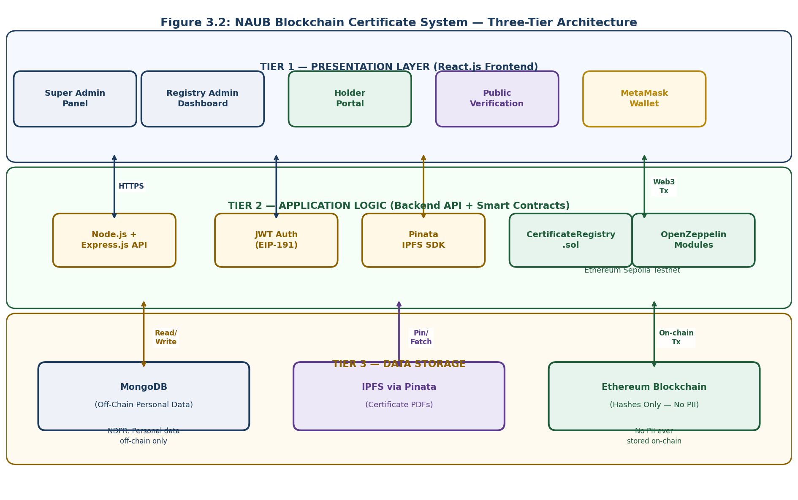
Figure 3.2: NAUB Blockchain Certificate System — Three-Tier Decentralised Application Architecture

3.5.2 Technology Stack
Layer | Technology | Version | Purpose
Smart Contracts | Solidity | 0.8.19 | Certificate registry and role management contract logic
Security Libraries | OpenZeppelin Contracts | 4.9.3 | AccessControl, Pausable, ReentrancyGuard modules
Dev Framework | Hardhat | 2.19 | Compilation, testing, deployment, and Sepolia interaction
Blockchain Network | Ethereum Sepolia Testnet | Active | Public test network for all development and evaluation
Blockchain Library | Ethers.js | 6.9 | Frontend wallet connection, transaction signing, contract calls
Wallet | MetaMask | Latest | Browser extension for Ethereum account management
Frontend Framework | React.js | 18 | Component-based single-page application UI
Frontend Build Tool | Vite | 5.0 | Fast development server and production bundler
Backend Runtime | Node.js | 20 LTS | Server-side JavaScript runtime for Express API
Backend Framework | Express.js | 4.18 | REST API routing, middleware, and request handling
Database | MongoDB | 6.0 | Off-chain NoSQL document database for personal data
ODM | Mongoose | 8.0 | MongoDB schema definition, validation, and query interface
File Storage | IPFS via Pinata | Latest SDK | Certificate PDF pinning and content-addressed retrieval
Hash Function | SHA-256 (Web Crypto API) | W3C Standard | Browser-side certificate field hashing before transmission
Authentication | EIP-191 + JWT | Standards | Wallet signature verification and stateless session tokens
Testing | Hardhat + Mocha + Chai | Latest | Smart contract unit and integration testing framework
Security Analysis | Slither | Latest | Static analysis of Solidity contracts for vulnerabilities
Table 3.3: Complete Technology Stack

3.6 Smart Contract Design

3.6.1 Contract Architecture
The blockchain layer of the NAUB system is implemented as a single smart contract named CertificateRegistry, written in Solidity version 0.8.19 and inheriting from three OpenZeppelin base contracts. The first is AccessControl, which provides the role-based permission system. The second is Pausable, which provides the emergency halt mechanism. The third is ReentrancyGuard, which prevents reentrancy attacks on state-modifying functions. The decision to use a single contract rather than separate contracts for role management and certificate management was made to keep gas costs low and deployment straightforward. Figure 3.3 below illustrates the complete internal structure of the CertificateRegistry contract.

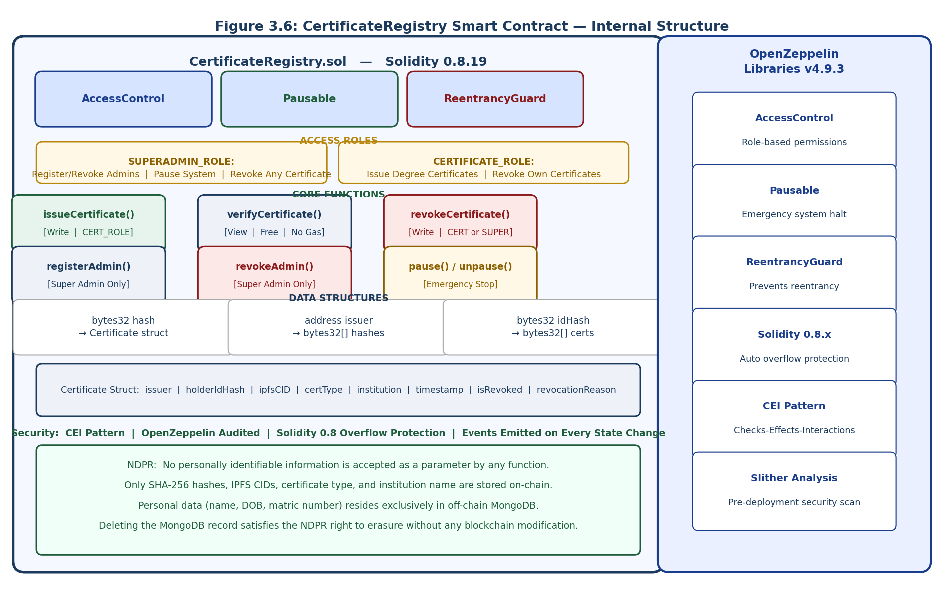
Figure 3.3: CertificateRegistry Smart Contract — Internal Structure, Roles, Functions, and Security Measures

3.6.2 Role Structure
The contract defines two roles in addition to the default admin role provided by OpenZeppelin's AccessControl module. The SUPERADMIN_ROLE is assigned to the wallet address of the NAUB Registrar or Vice Chancellor's office at deployment. It grants the ability to register and revoke Registry Admin wallets, pause and unpause the contract, and revoke any certificate regardless of who issued it. The CERTIFICATE_ROLE is assigned to Registry Admin wallets by a Super Admin and grants the ability to issue and revoke degree certificates. All other wallet addresses, including every public verifier and every certificate holder, have no role and can only call the read-only view functions, which are publicly accessible by design.
Role assignments are enforced at the transaction level through the onlyRole modifier inherited from OpenZeppelin's AccessControl contract. When a wallet submits a transaction calling a role-protected function, the modifier checks whether the calling address holds the required role before executing any function logic. If the check fails, the transaction is automatically reverted and no state change occurs. This enforcement happens at the Ethereum Virtual Machine level, independently of any application server or administrator decision, meaning that no amount of social engineering or database manipulation can bypass it.
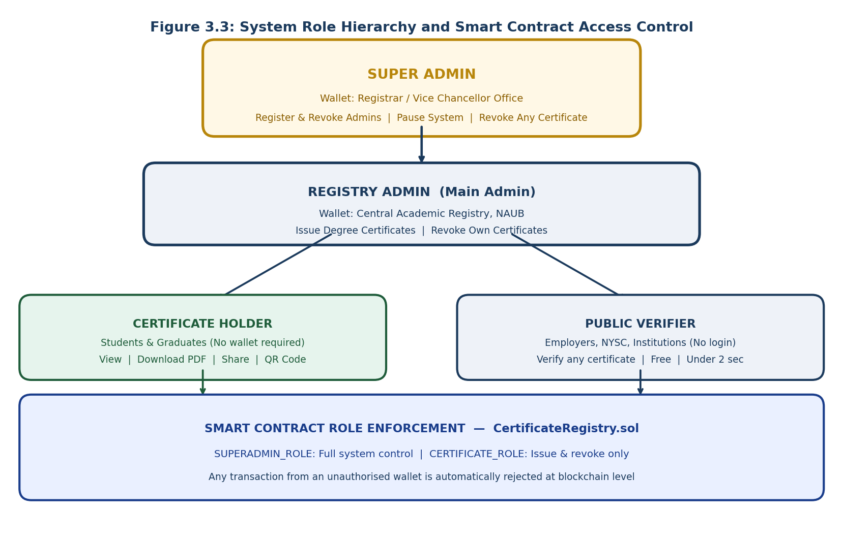
Figure 3.3a: System Role Hierarchy — Four Roles Enforced at Smart Contract Level

3.6.3 Certificate Data Structure
Each certificate is represented on-chain by a Solidity struct with the following fields: the wallet address of the issuing Registry Admin; the bytes32 identity hash of the certificate holder, derived from the SHA-256 hash of the student's full name and date of birth concatenated with the institution identifier; the IPFS Content Identifier of the certificate PDF document stored as a string; the certificate type as a string set to the value "DEGREE" in the current implementation scope; the institution name as a string set to "NAUB"; the block timestamp at the time of issuance as a uint256 value; a boolean flag indicating whether the certificate has been revoked; and a string containing the revocation reason, which is empty for certificates that have not been revoked.
Certificates are stored in a mapping from bytes32 hash to Certificate struct. The bytes32 hash key is the SHA-256 hash of all certificate field values computed in the browser and submitted with the issuance transaction. Two additional mappings index certificates by issuer address and by holder identity hash respectively, allowing efficient retrieval of all certificates associated with a given Registry Admin or a given student without requiring a full scan of the certificate mapping. The use of mappings rather than arrays ensures that lookup and retrieval operations are O(1) in complexity regardless of the total number of certificates stored.

3.6.4 Core Functions
The issueCertificate function accepts the certificate hash, holder identity hash, IPFS Content Identifier, certificate type, and institution name as parameters. It is protected by the onlyRole(CERTIFICATE_ROLE) modifier and the nonReentrant modifier from OpenZeppelin. Before writing any state, it validates that the certificate hash is not already present in the mapping, that the system is not paused, and that all required parameters are non-empty. If all validations pass, it writes the Certificate struct to the mapping, adds the hash to the issuer and holder index mappings, and emits a CertificateIssued event containing the hash, issuer address, and timestamp.
The verifyCertificate function is declared as a view function, which means it reads blockchain state without modifying it and therefore costs zero gas to call. It accepts a certificate hash as its single parameter and returns the full Certificate struct associated with that hash, or a zero-value struct if no matching record exists. The read-only nature of this function is the reason why public verification in the NAUB system is permanently free for any user anywhere in the world.
The revokeCertificate function accepts a certificate hash and a revocation reason string. It is protected by a custom modifier that allows the call if the sender holds either the SUPERADMIN_ROLE or the CERTIFICATE_ROLE, subject to the additional restriction that a Registry Admin can only revoke certificates they issued themselves, while a Super Admin can revoke any certificate. The function validates that the certificate exists and is not already revoked, then sets the isRevoked flag to true, records the revocation reason and block timestamp, and emits a CertificateRevoked event.

3.6.5 Security Measures
Beyond the OpenZeppelin module protections, the contract applies three additional security principles throughout its implementation. The checks-effects-interactions pattern is applied to every state-modifying function: all input validation checks are completed first, then all state variables are updated, and external calls or event emissions occur last. This ordering prevents any reentrancy attack from exploiting incomplete state. The contract uses Solidity 0.8.19, which provides automatic arithmetic overflow and underflow protection. The contract emits events for every significant state change, creating a permanent, queryable audit log that can be monitored independently by any party without access to the Node.js backend.

3.7 Backend Application Programming Interface Design

3.7.1 API Architecture
The backend REST API is implemented using Node.js version 20 LTS and the Express.js version 4.18 framework. It follows the Model-View-Controller architectural pattern, with Mongoose models defining the MongoDB data schemas, Express route handlers acting as controllers, and the React.js frontend consuming the API as the view layer. The API is stateless: no session state is maintained on the server between requests. Authentication state is carried entirely in the JWT token issued at login, which the client presents with each subsequent request.

3.7.2 Authentication: EIP-191 Wallet Signatures and JWT
Authentication in the NAUB system is based on Ethereum wallet ownership rather than a conventional username and password. When a Registry Admin or Super Admin wishes to log in, the API generates a random nonce and returns it to the client. The client's MetaMask wallet signs this nonce using the EIP-191 personal message signing standard, which produces a signature that proves the client controls the private key corresponding to a given Ethereum wallet address without revealing the private key itself. The API verifies the signature using the Ethers.js library, recovers the signing address, checks that this address holds an appropriate role in the CertificateRegistry smart contract, and if it does, issues a signed JWT token with an eight-hour expiry.
Subsequent requests from the authenticated client include the JWT in the Authorization header. The JWT middleware on the API verifies the token signature and expiry before allowing the request to proceed to the route handler. This design means that admin authentication is ultimately grounded in blockchain-confirmed role membership rather than a database password, so compromising the MongoDB database does not allow an attacker to forge admin credentials.

3.7.3 MongoDB Data Schemas and NDPR Architecture
The MongoDB database uses five Mongoose schemas corresponding to the entities defined in the Entity Relationship Diagram presented in the System Design Diagrams document. The Certificate schema stores all certificate metadata including the certificate hash, all personal data fields, the IPFS Content Identifier, the issuer wallet address, the issuance timestamp, the revocation status, and the revocation reason. A toPublicJSON instance method is defined on the Certificate model that returns a version of the document with all personally identifiable fields removed, retaining only the certificate hash, IPFS Content Identifier, programme, class of degree, date of award, institution, and revocation status. This method is called on every certificate object before it is included in any API response that is not protected by admin JWT authentication, ensuring that personal data is never exposed to the holder portal or the public verification interface through the API layer.
The right-to-erasure endpoint, required by NDPR Article 3.1(6), accepts a verified erasure request and permanently deletes the Certificate and Student documents from MongoDB associated with the specified matriculation number and date of birth combination. The on-chain hash record cannot be deleted, but because the MongoDB record that links the hash to the student's personal information has been deleted, the hash becomes permanently anonymous. This satisfies the right to erasure under the NDPR without any modification to the blockchain.

3.7.4 API Endpoint Summary
Method | Endpoint | Auth | Description
POST | /api/auth/nonce | None | Generate and return a nonce for wallet signature authentication
POST | /api/auth/verify | None | Verify EIP-191 wallet signature, confirm role on blockchain, issue JWT
POST | /api/certificates/issue | JWT (Admin) | Validate fields, upload PDF to IPFS, save to MongoDB, return hash + CID
GET | /api/certificates/issuer/:address | JWT (Admin) | Retrieve all certificates issued by a specific Registry Admin wallet
GET | /api/certificates/holder/:idHash | None | Retrieve all certificates for a given anonymised holder identity hash
GET | /api/certificates/:hash | None | Retrieve certificate metadata by hash (public-safe fields only)
POST | /api/certificates/:hash/revoke | JWT (Admin) | Record revocation reason in MongoDB; transaction handled on frontend
DELETE | /api/certificates/erasure | JWT (Admin) | NDPR right to erasure: delete all personal data for specified student
POST | /api/admins/register | JWT (Super) | Record new Registry Admin details in MongoDB after on-chain role assignment
GET | /api/admins | JWT (Super) | Retrieve list of all registered Registry Admin accounts
GET | /api/verify/:hash | None | Public verification route: query MongoDB for display details of a hash
POST | /api/logs/verification | None | Record verification event in VerificationLog collection
Table 3.4: Backend API Endpoint Reference

3.8 Frontend Decentralised Application Design

3.8.1 Application Structure
The frontend application is a single-page application built with React.js version 18 and the Vite version 5.0 build tool. It is structured around four distinct portal interfaces, each corresponding to one of the four user roles, plus a shared MetaMask wallet connection context that manages the Ethers.js provider and signer objects used for blockchain interaction. The application communicates with the backend API over HTTPS for all data management operations and communicates directly with the Ethereum Sepolia Testnet through the Ethers.js library and the MetaMask browser extension for all transaction signing operations.

3.8.2 Super Admin Panel
The Super Admin Panel is accessible only to a wallet address that holds the SUPERADMIN_ROLE on the CertificateRegistry contract. After connecting their MetaMask wallet, the panel displays all currently registered Registry Admins, the system pause status, and a log of recent governance transactions. The Super Admin can register a new Registry Admin by entering a wallet address, which triggers an Ethers.js call to the registerAdmin function on the smart contract, prompting MetaMask to request transaction confirmation. The Super Admin can revoke an existing Registry Admin by selecting their entry and confirming the revokeAdmin transaction. An emergency pause button calls the pause function on the contract, disabling all certificate issuance operations until the Super Admin resumes the system.

3.8.3 Registry Admin Dashboard
The Registry Admin Dashboard is accessible only to wallets holding the CERTIFICATE_ROLE. It presents the admin with a list of all certificates they have issued and a certificate issuance form. The form collects the student's full name, matriculation number, date of birth, programme of study, class of degree, date of award, certificate number, and the Vice Chancellor's name. Upon form submission, the browser computes the SHA-256 hash of all field values concatenated in a fixed canonical order, using the SubtleCrypto interface of the Web Crypto API. This computation happens entirely on the client, before any network request is made. The certificate PDF is then uploaded to the backend API, which forwards it to IPFS via the Pinata SDK and returns the IPFS Content Identifier. Finally, MetaMask is invoked to sign and submit the issueCertificate transaction to the deployed contract. Upon blockchain confirmation, the frontend displays the transaction hash, the certificate hash, a QR code, and the IPFS PDF link to the admin.
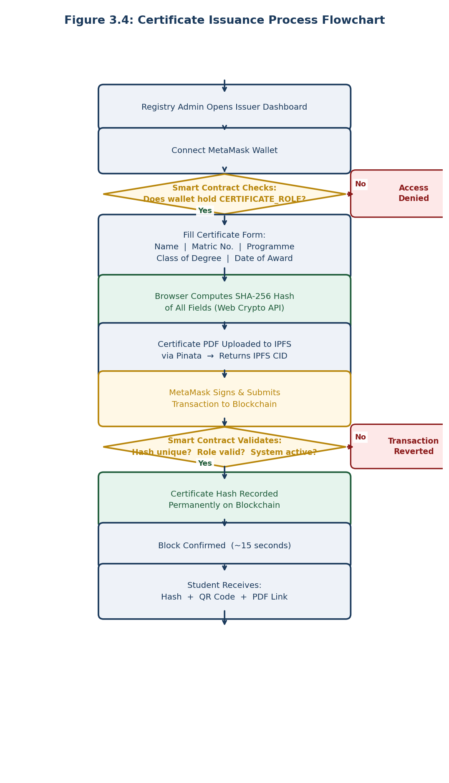
Figure 3.4a: Certificate Issuance Process Flowchart — Registry Admin Workflow

3.8.4 Holder Portal
The Holder Portal is designed to be accessible without any MetaMask wallet or blockchain knowledge. A student or graduate enters their full name and date of birth into the portal. The browser hashes these values using the same SHA-256 concatenation scheme used during issuance to produce the holder identity hash. The portal then calls the GET /api/certificates/holder/:idHash endpoint, which queries the MongoDB database for all certificates associated with that identity hash and returns the public-safe fields for each one. The portal displays a certificate card for each record, showing the programme, class of degree, date of award, and verification status. From each card, the holder can download the certificate PDF from the IPFS link, copy the verification hash to the clipboard, generate a shareable verification URL, or generate a QR code for physical presentation.

3.8.5 Public Verification Page
The Public Verification Page is fully accessible without any form of login or registration. It presents four tabs corresponding to the four input methods supported by the system. The first tab accepts a certificate hash pasted directly by the verifier. The second tab presents the same form fields used during issuance and computes the hash from the entered values, allowing a verifier who has access to the original certificate data to reproduce the hash independently. The third tab accepts a certificate PDF upload and extracts the embedded hash from the document metadata. The fourth tab activates the device camera for a QR code scan, which decodes the certificate URL and extracts the hash parameter. All four tabs submit the same hash value to the same verification function, which calls the verifyCertificate view function on the CertificateRegistry smart contract via Ethers.js. The result is displayed within two seconds as one of three clearly styled outcomes: VERIFIED VALID with the full certificate details, REVOKED with the reason and revocation date, or NOT FOUND with a warning that the certificate may not be genuine.
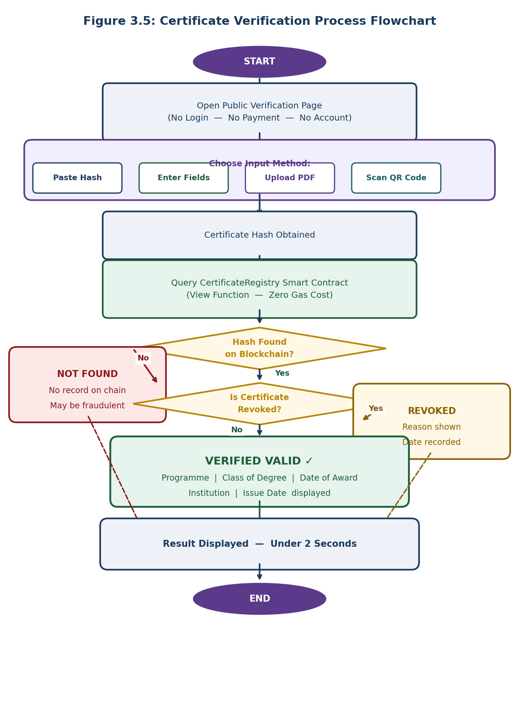
Figure 3.5a: Certificate Verification Process Flowchart — Public Verifier Workflow

3.9 NDPR Compliance Architecture
The NDPR compliance architecture of the NAUB system is built on one foundational principle: no personally identifiable information is ever written to the Ethereum blockchain. This principle resolves the conflict between blockchain immutability and the NDPR right to erasure described in Chapter Two. Figure 3.4 below illustrates the strict off-chain and on-chain data separation that enforces this principle across all three system layers.
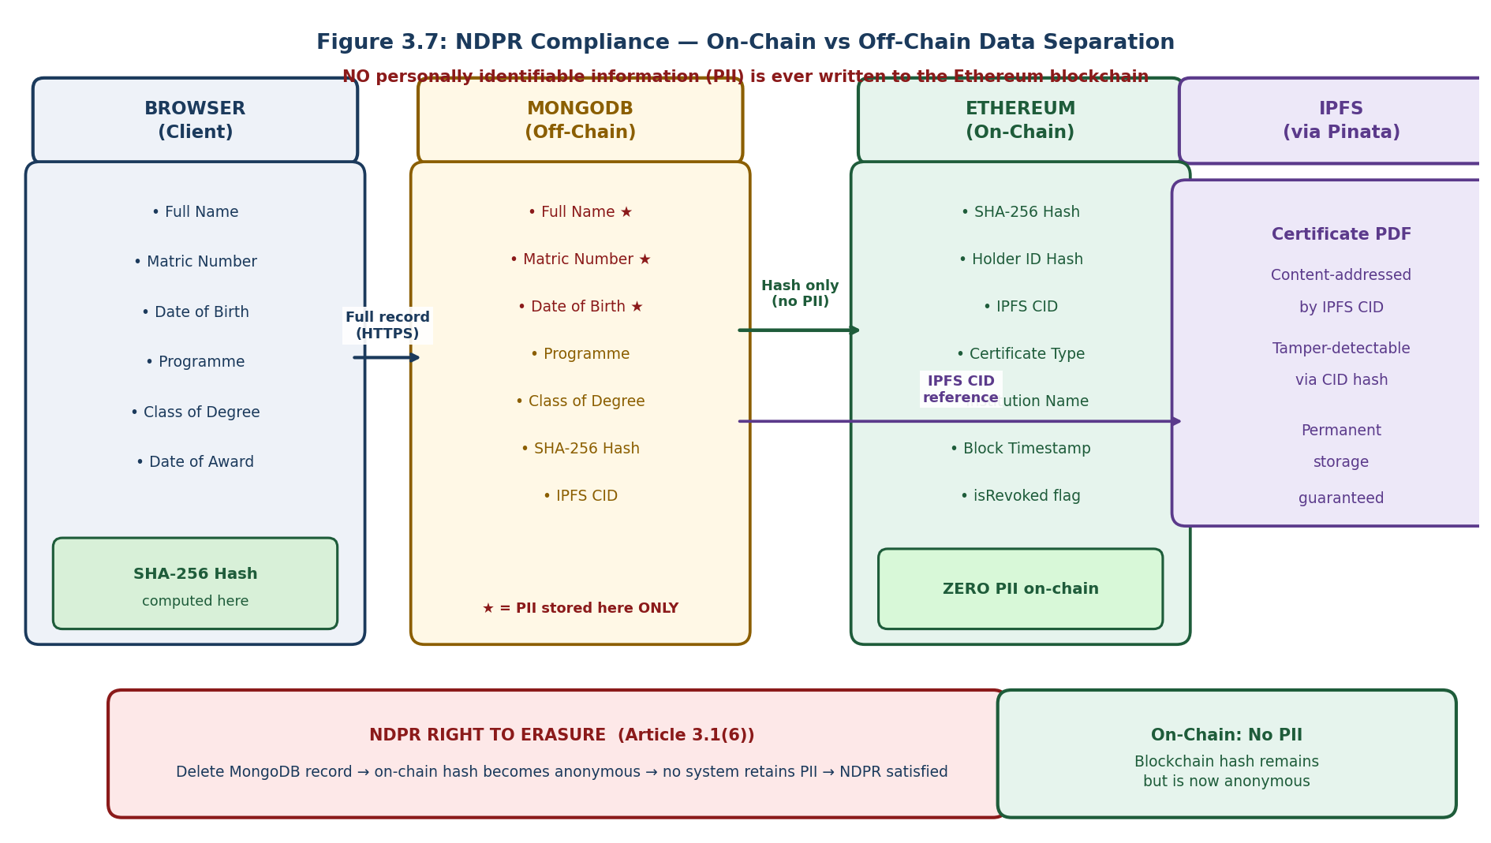
Figure 3.4: NDPR Compliance — On-Chain vs Off-Chain Data Separation Architecture
At the frontend layer, the SHA-256 hash of the certificate fields is computed in the browser before any data is transmitted to the backend API. The hash, not the plaintext data, is what is ultimately written to the blockchain. The plaintext data travels from the browser to the backend API over an encrypted HTTPS connection, where it is saved to the MongoDB database. At no point does the plaintext data touch the Ethereum network.
At the smart contract layer, the issueCertificate function accepts only the certificate hash, the holder identity hash, the IPFS Content Identifier, the certificate type, the institution name, and the timestamp as parameters. None of these parameters contain a student's name, date of birth, or matriculation number. The certificate hash is a one-way transformation of those values. It confirms that a specific set of values existed at the time of issuance without revealing what those values were to anyone examining the blockchain.
At the data management layer, the right-to-erasure endpoint deletes the Certificate and Student MongoDB documents on receipt of a verified erasure request. After deletion, the blockchain retains the certificate hash as an anonymous record of a degree certificate issued by NAUB on a specific date. No personal data is exposed by this record because the personal data needed to interpret it has been destroyed. This satisfies the NDPR right to erasure as established in Article 3.1(6) of the regulation (NITDA, 2019). The data minimisation principle is further satisfied by the design of the public verification response, which returns only the programme of study, class of degree, date of award, institution, and revocation status, without exposing any personal data from the off-chain database.

3.10 Testing and Evaluation Plan

3.10.1 Smart Contract Unit Testing
Smart contract unit testing is conducted using the Hardhat testing framework with the Mocha test runner and the Chai assertion library. A total of 32 unit tests are written to cover all functions in the CertificateRegistry contract. The tests are organised into seven suites covering: deployment and initial role assignment; certificate issuance under valid conditions; certificate issuance rejection under invalid conditions including duplicate hashes, paused state, and insufficient role; certificate verification for valid certificates; certificate verification for revoked certificates; certificate verification for non-existent hashes; and admin management including role assignment and revocation by the Super Admin. Each test is independent and uses the Hardhat network's snapshot and restore functionality to reset contract state between test suites.

3.10.2 Integration Testing
Integration testing is conducted against the live Sepolia Testnet deployment using the Hardhat console and a set of 40 automated integration test scripts. Integration tests verify that the complete workflow functions correctly end-to-end: issuance from the frontend triggers a blockchain transaction that is confirmed on Sepolia and recorded in MongoDB, verification queries return correct results matching the blockchain state, revocation is reflected immediately in verification results, and the holder portal retrieves the correct certificates for a given identity hash. Integration tests also verify that access control works correctly under network conditions, confirming that transactions submitted by wallets without the required role are rejected by the live contract.

3.10.3 Performance Testing
Performance testing measures two categories of response time. The first is the blockchain verification response time, measured as the elapsed time from the submission of a hash to the display of a verification result across 50 queries to the live Sepolia contract. The target is a mean response time below 2,000 milliseconds. The second is the backend API response time, measured for each API endpoint category across 40 requests. Gas costs for the two state-modifying contract functions, issueCertificate and revokeCertificate, are measured on Sepolia and converted to Nigerian Naira equivalent at the prevailing exchange rate.

3.10.4 Security Analysis
Static security analysis of the CertificateRegistry Solidity contract is conducted using the Slither static analysis tool developed by Trail of Bits. Slither is run against the contract source code and all findings are categorised by severity level. The deployment precondition requires zero HIGH severity and zero MEDIUM severity findings. LOW severity findings are reviewed individually and either addressed or documented with justification if they represent acceptable design trade-offs. Slither is run both before deployment and again after any contract modification to confirm that no new findings have been introduced.

3.10.5 Usability Evaluation
The usability of the NAUB system is evaluated using the System Usability Scale, a standardised ten-item Likert questionnaire developed by Brooke (1996) that produces a single usability score on a scale of zero to one hundred. The SUS was selected because it is technology-agnostic, requires no specialist knowledge to administer, has extensive published benchmarks for interpreting scores, and has been validated across a wide range of application types and user populations.

Ten participants are recruited for the usability study, consistent with the guidance of Nielsen (1993) that five to ten participants are sufficient to identify the majority of usability issues in a formative evaluation context. The ten participants are distributed across three role groups: three participants assigned to the Registry Admin role, four participants assigned to the Public Verifier role, and three participants assigned to the Holder role. Table 3.5 below presents the ten SUS questionnaire items administered to each participant.

Item No. | SUS Questionnaire Statement | Scoring
1 | I think that I would like to use this system frequently. | Odd: score - 1
2 | I found the system unnecessarily complex. | Even: 5 - score
3 | I thought the system was easy to use. | Odd: score - 1
4 | I think that I would need the support of a technical person to be able to use this system. | Even: 5 - score
5 | I found the various functions in this system were well integrated. | Odd: score - 1
6 | I thought there was too much inconsistency in this system. | Even: 5 - score
7 | I would imagine that most people would learn to use this system very quickly. | Odd: score - 1
8 | I found the system very cumbersome to use. | Even: 5 - score
9 | I felt very confident using the system. | Odd: score - 1
10 | I needed to learn a lot of things before I could get going with this system. | Even: 5 - score
Table 3.5: System Usability Scale (SUS) Questionnaire Items (Brooke, 1996)
The SUS scoring procedure defined by Brooke (1996) is applied to each completed questionnaire: for odd-numbered items, the score contribution is the participant's response minus one; for even-numbered items, the score contribution is five minus the participant's response; the sum of all ten contributions is multiplied by 2.5 to yield a final score out of one hundred. The mean SUS score across all ten participants is compared against the adjective scale published by Bangor, Kortum, and Miller (2008) to produce a qualitative usability verdict.

3.11 Implementation Plan
The implementation of the NAUB Blockchain Certificate System follows a phased approach structured across five phases corresponding to the five major system components. Phase One, occupying Weeks 1 to 3, covers requirements elicitation, system design, and the establishment of the development environment. Phase Two, occupying Weeks 3 to 5, covers the development, testing, and Sepolia deployment of the CertificateRegistry smart contract. Phase Three, occupying Weeks 6 to 8, covers the implementation of the Node.js backend API, MongoDB schemas, and Pinata IPFS integration. Phase Four, occupying Weeks 9 to 11, covers the development of all four React.js portal interfaces and their end-to-end integration with the backend API and the live Sepolia contracts. Phase Five, occupying Weeks 12 to 14, covers all testing, evaluation, gas cost measurement, usability study administration, and the completion of Chapters Four and Five. Figure 3.5 presents the complete Gantt chart for the 14-week implementation schedule.


Figure 3.5: NAUB Blockchain Certificate System — 14-Week Implementation Gantt Chart

The critical dependency chain that governs the sequencing of the implementation is as follows: the smart contract must be deployed before the backend API can be tested against live blockchain state, the backend API must be functional before the frontend application can complete its integration, and all three components must be working end-to-end before the usability study can be conducted on the live system. Any delay in Phase Two therefore carries through to all subsequent phases, which is why the milestone requirement of zero Slither HIGH findings before Sepolia deployment is treated as non-negotiable rather than aspirational.

3.12 Chapter Summary
This chapter has established the Design Science Research paradigm as the methodological foundation for the project and presented the DSR six-activity cycle as applied to this research. It described the primary and secondary data collection methods used to inform the system requirements, including the purposive sampling strategy, the five-person structured interview protocol with its interview guide, and the document analysis of the NAUB Academic Regulations and the NDPR 2019. It presented 16 functional requirements and 10 non-functional requirements, each with clear traceability to the problem statement in Chapter One and the design decisions described in this chapter. The three-tier decentralised application architecture was illustrated with a system diagram, and the complete technology stack was tabulated. The CertificateRegistry smart contract design, including its role structure, data structures, core functions, and security measures, was presented with a contract structure diagram. The NDPR compliance architecture was explained and illustrated with an on-chain versus off-chain data separation diagram. The testing and evaluation plan was described, including the full SUS questionnaire instrument. The chapter concluded with the 14-week implementation Gantt chart. Chapter Four presents the outcomes of implementing this plan and the results of all evaluation activities.

REFERENCES
Adewale, O. S., Adewumi, A., & Usman, A. D. (2021). A blockchain framework for academic certificate authentication in Nigeria. International Journal of Advanced Computer Science and Applications, 12(8), 112-121. https://doi.org/10.14569/IJACSA.2021.0120816
Akinnifesi, A. S., & Balogun, J. M. (2025). Design and implementation of a blockchain-based certificate verification system for secure academic credential authentication. University of Ibadan Journal of Science and Logics in ICT Research, 15. https://journals.ui.edu.ng/index.php/uijslictr/article/view/2065
Bangor, A., Kortum, P. T., & Miller, J. T. (2008). An empirical evaluation of the System Usability Scale. International Journal of Human-Computer Interaction, 24(6), 574-594. https://doi.org/10.1080/10447310802205776
Benet, J. (2014). IPFS: Content addressed, versioned, P2P file system. arXiv preprint arXiv:1407.3561. https://arxiv.org/abs/1407.3561
Brooke, J. (1996). SUS: A quick and dirty usability scale. In P. W. Jordan, B. Thomas, B. A. Weerdmeester, & A. L. McClelland (Eds.), Usability evaluation in industry (pp. 189-194). Taylor and Francis.
Buterin, V. (2014). A next generation smart contract and decentralized application platform. Ethereum White Paper. https://ethereum.org/whitepaper
Creswell, J. W. (2014). Research design: Qualitative, quantitative, and mixed methods approaches (4th ed.). SAGE Publications.
Economic and Financial Crimes Commission (EFCC). (2022). Annual report 2022. EFCC Publications.
Ethereum Foundation. (2023). Ethereum documentation. https://ethereum.org/developers/docs
Ethereum Foundation. (2023). Ethereum documentation: Proof-of-stake. https://ethereum.org/developers/docs/consensus-mechanisms/pos
Federal Government of Nigeria. (2020). National Digital Economy Policy and Strategy 2020-2030. Federal Ministry of Communications and Digital Economy.
Habib, G., Sharma, S., Ibrahim, S., Ahmad, I., Qureshi, S., & Ishfaq, M. (2022). Blockchain technology: Benefits, challenges, applications, and integration of blockchain technology with cloud computing. Future Internet, 14(11), 341. https://doi.org/10.3390/fi14110341
Hevner, A. R., March, S. T., Park, J., & Ram, S. (2004). Design science in information systems research. MIS Quarterly, 28(1), 75-105. https://doi.org/10.2307/25148625
Ifeyemi, O., Oyedeji, A. O., & Adebiyi, M. O. (2024). Blockchain-based digital certificate verification system. ITEGAM-JETIA, 10(49), 35-41. https://itegam-jetia.org/journal/index.php/jetia/article/download/1145/814/
Independent Corrupt Practices and Other Related Offences Commission (ICPC). (2021). Annual report 2021. ICPC Publications.
Kshetri, N., & Voas, J. (2018). Blockchain-enabled e-voting. IEEE Software, 35(4), 95-99. https://doi.org/10.1109/MS.2018.2801546
Kushwaha, S. S., Joshi, S., Singh, D., Kaur, M., & Lee, H. N. (2022). Systematic review of security vulnerabilities in Ethereum blockchain smart contract. IEEE Access, 10, 6605-6621. https://doi.org/10.1109/ACCESS.2022.3142668
Nakamoto, S. (2008). Bitcoin: A peer-to-peer electronic cash system. https://bitcoin.org/bitcoin.pdf
National Information Technology Development Agency (NITDA). (2019). Nigeria Data Protection Regulation 2019. Federal Government of Nigeria. https://nitda.gov.ng/ndpr
National Information Technology Development Agency (NITDA). (2025). NITDA Blockchain Certificate System. https://nitda-blockchain-cert.vercel.app/
National Institute of Standards and Technology (NIST). (2015). Secure Hash Standard (SHS), FIPS Publication 180-4. https://doi.org/10.6028/NIST.FIPS.180-4
National Youth Service Corps (NYSC). (2021). NYSC 2021 annual report. NYSC Directorate Headquarters.
Nielsen, J. (1993). Usability engineering. Academic Press.
Ofoegbu, G. E., & Nwachukwu, C. E. (2015). Certificate racketeering in the Nigerian educational system. Journal of Educational and Social Research, 5(3), 212-219. https://doi.org/10.5901/jesr.2015.v5n3p212
Onoshioze, O. E., Ahubele, B. O., & Obahiagbon, K. O. (2025). Academic certificate verification framework using blockchain technology. BIU Journal of Basic and Applied Sciences, 10(1). https://oer.biu.edu.ng/wp-content/uploads/2025/05/BIUJBAS-101_4.pdf
OpenZeppelin. (2023). OpenZeppelin Contracts v4.x documentation. https://docs.openzeppelin.com/contracts/4.x
Patton, M. Q. (2002). Qualitative research and evaluation methods (3rd ed.). SAGE Publications.
Peffers, K., Tuunanen, T., Rothenberger, M. A., & Chatterjee, S. (2007). A design science research methodology for information systems research. Journal of Management Information Systems, 24(3), 45-77. https://doi.org/10.2753/MIS0742-1222240302
Rustemi, A., Dalipi, F., Atanasovski, V., & Risteski, A. (2023). A systematic literature review on blockchain-based systems for academic certificate verification. IEEE Access, 11, 64679-64696. https://doi.org/10.1109/ACCESS.2023.3289598
Sa'ad, S., Sani, A. C., Ribadu, M. B., & Mohammed, A. (2024). Enhancing security and accessibility of personal records in Nigeria using blockchain technology: A case study of Modibbo Adama University, Yola. International Journal of Development Mathematics (IJDM), 1(4), 236-248. https://ijdm.org.ng/index.php/Journals/article/view/71
Said, S. H., Dida, M. A., Kosia, E. M., & Sinde, R. S. (2023). A blockchain-based conceptual model to address educational certificate verification challenges in Tanzania. Engineering, Technology and Applied Science Research, 13(5), 11691-11704. https://doi.org/10.48084/etasr.6170
Solidity Documentation. (2023). Solidity v0.8.x language reference. https://docs.soliditylang.org/en/v0.8.19/
Szabo, N. (1994). Smart contracts. Unpublished manuscript. https://www.fon.hum.uva.nl/rob/Courses/InformationInSpeech/CDROM/Literature/LOTwinterschool2006/szabo.best.vwh.net/smart.contracts.html
West African Examinations Council (WAEC). (2022). WAEC annual report 2022. WAEC West Africa Headquarters.

